## Story ID 18

User Story: As the coordinator I want to be able to manually assign drivers to deliveries in precise locations so that I can control the efficiency of them.

* From the deliveries screen, I am able to view all current packages awaiting assignment or assigned to drivers, as an employee. I can view all information available on those packages, such as date of delivery, and the address and postcode where it will be delivered to.

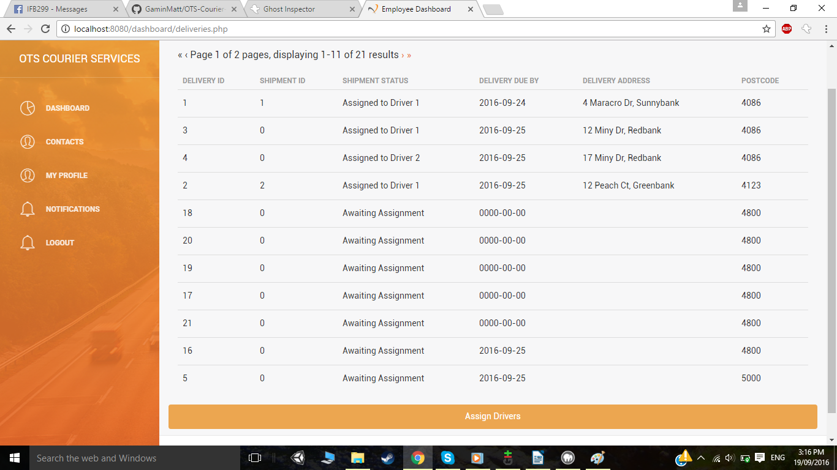

* As the coordinator, I can see and click on the Assign Drivers button, which takes me to the Assignment page where I can assign packages which are awaiting assignment, to drivers.

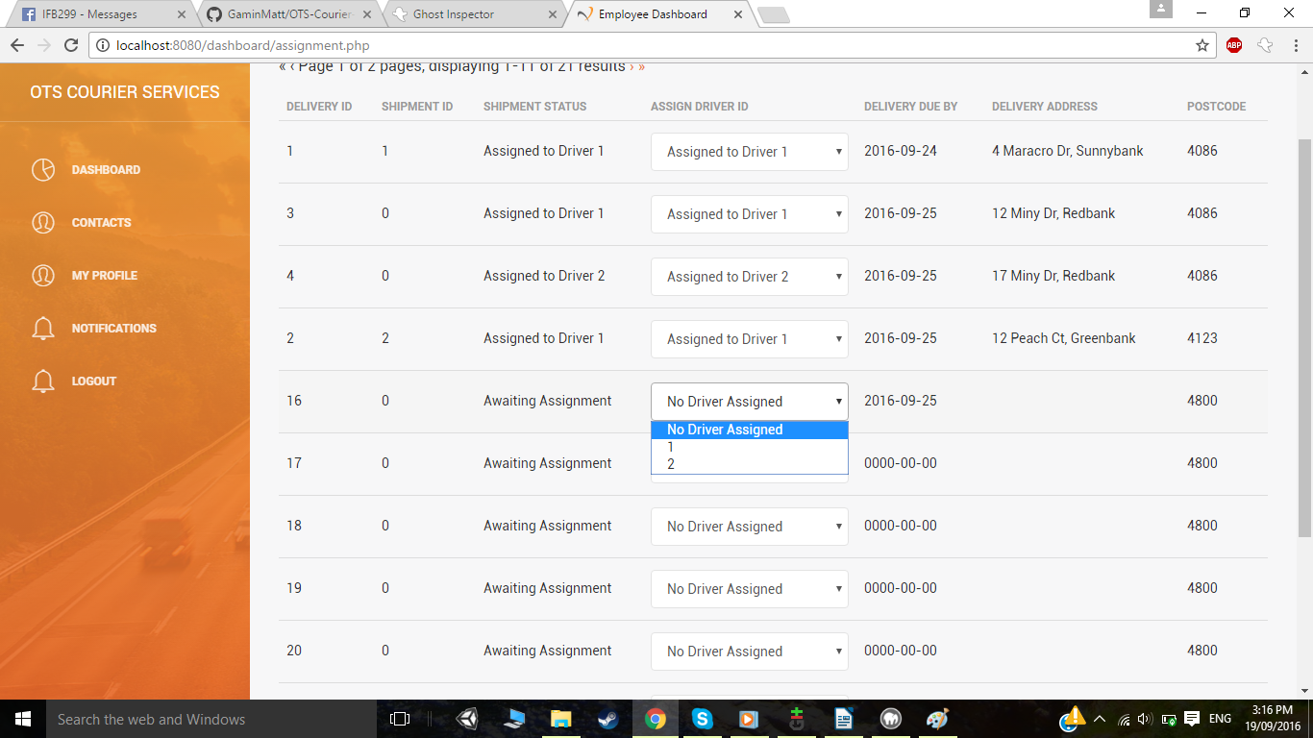

* Once a Driver ID is selected, the package is assigned to that driver and the database is updated.

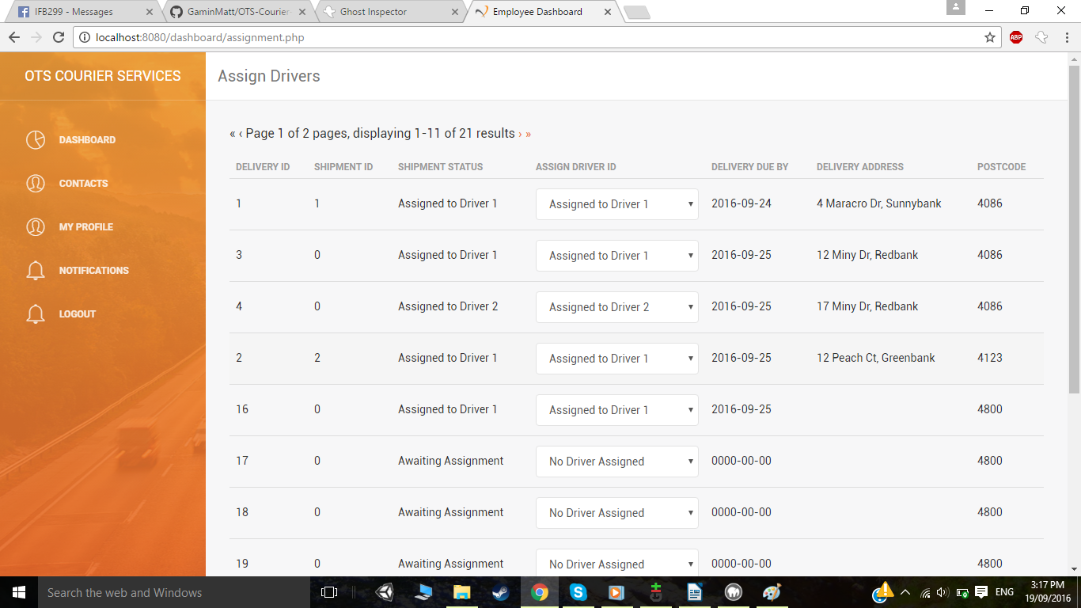

* To reassign packages that have already been assigned, I can click on that package's drop down menu and select a new driver ID.

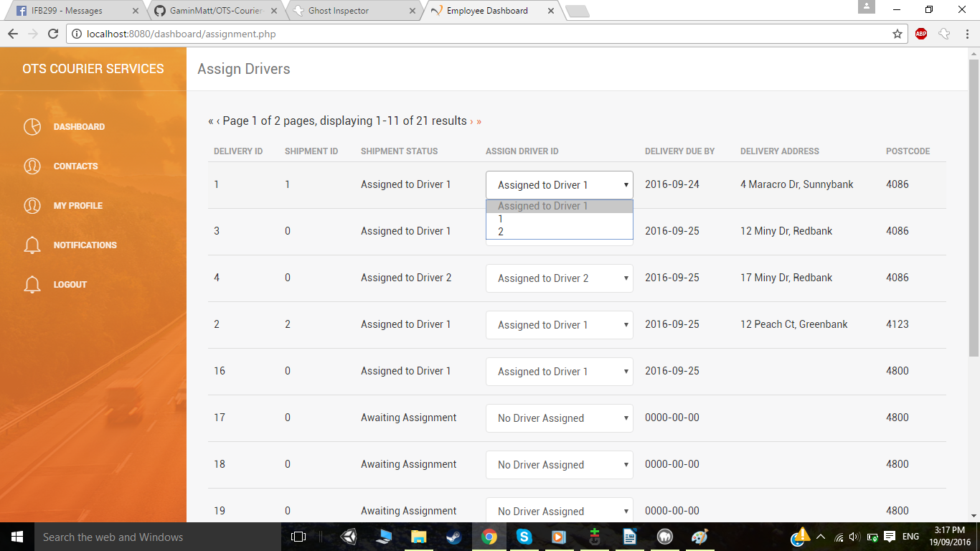

* Again, clicking on the Driver ID will assign the package to that specific driver.

